|  |  |
| --- | --- |
| *Module* | **Budget Plan** |
| *to* | B.TECH |
| *by* | ReBO Solutions |

Functional Documentation



Table of contents

**1. Introduction**4

1.1 Assumptions 4

1.2 Source Data 4

**2. BP Functionalities**5-9

2.1. Login Screen 5

2.2. Main Menu 6

2.3. BP – First Level Filtering 6

2.4. Second Level Filtering 7

2.5. Third level Filtering 7-8

2.6. Search Result Screen 9

2.7. Forecast overview 10-11

2.8. Input fields in the grid 12

2.9. BP List and Details 13

**3. BMAPS BP Approval Table** 13-14

3.1. BP Access Control 13-14

|  |  |  |
| --- | --- | --- |
| **Authors** | | |
| **Name** | **Role** | **Department** |
| Madhu Ravindran | Technical Architect | REBO – IT |
| Elvis | Functional Architect | REBO – IT |

|  |  |  |  |
| --- | --- | --- | --- |
| **Document History** | | | |
| **Date** | **Version** | **Document Revision Description** | **Document Author** |
| 10th May 23 | V1 | BP Functional Specification document | Elvis |
|  |  |  |  |
|  |  |  |  |
|  |  |  |  |
|  |  |  |  |

|  |  |  |  |
| --- | --- | --- | --- |
| **Approvals** | | | |
| **Approval Date** | **Approved Version** | **Approver Role** | **Approver** |
|  |  |  |  |
|  |  |  |  |
|  |  |  |  |
|  |  |  |  |

Document history and approvals

# **Introduction**

Introduction

The Budget planning allocation is based on the assortment performance & financial goals.

Budget plan is an extensive model created to forecast and plan the business budget for a week/month/annual. This module shall be used for supporting better decision-making. It is a comprehensive file which powers the user to alter the budget plan to achieve high degree of accuracy & leverage to manage the KPI’s.

The following criteria are considered for the module:

* The last version of the approved Budget allocated in the strategic plan/ Range Architecture/ OTB.
* The period or season selection
* The hierarchy selection of channels, Family etc.,
* KPI
* Desired Sellthrough
* Distribution Value

## Assumptions

* Identify the Trading year/month/week.
* Determine Active/Non-Active locations
* Prepare the historical data and determine its performance.
* Predictive values for active business.

## Source Data

* Sales files at transactional level for all 3 channels for current year and previous year.
* Strategic plan file for the current year
* Store master data
* Store Mix Data

functionalities

# **BP Functionalities**

## Login Screen

|  |  |
| --- | --- |
| Fields | Functionality |
| Username | Use Active directory username for authentication |
| Password | Use Active Directory password |
| Sign in Button | Once signed in user will be able to access respective modules to which they have permission on |

functionalities

functionalities

## Main Menu

|  |  |
| --- | --- |
| Fields | Functionality |
| Main Menu Items | Once Logged in user will be able to access respective modules on which they have permission on |

## BP – First Level Filtering

functionalities

|  |  |
| --- | --- |
| Fields | Functionality |
| Sales Channel | Multi Dropdown with search filed – Online, Retail, BtechX, Tech Hub, B2B |
| Product Family | Multi Dropdown with search field - AC, Mobile, TV, etc. |
| Product Sub Family | Multi Dropdown with search field |
| Brand / Supplier | Multi Dropdown with search field |
| Category | Multi Dropdown with search field |
| Subcategory | Multi Dropdown with search field |
| Store Region | Multi Dropdown with search field |
| Store Grading | High Premium, High Medium, Low – Premium |
| Store List | Store Code with Location |
| Item Code | Multi Dropdown with search field - SKU |
| Top Items | Top 50, 100 Items |
| Class | Multi Dropdown with search field – A, B, C |
| Submit Button | Click on submit button to execute search as per the option selected |

functionalities

## Second Level Filtering

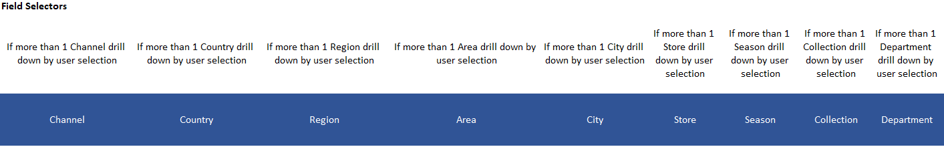

## Third Level Filtering

functionalities

functionalities

functionalities

## Search Result Screen

functionalities

* After the filter, the BP data will be displayed in Graph and Grid format.
* The value on the grid has to be segregated at price (gross & net), cost, quantity, margin and markdown which can be toggled through a tab method.
* The hierarchy should be year, month, week, day and SKU.
* The SKU data should be available at a higher level also based on the option selected on the top.
* All input cells should be highlighted in yellow
* If the data changes then the data in the cell will be highlighted with Orange color

|  |  |
| --- | --- |
| Fields | Functionality |
| Field Selector | Select required fields, fields are listed bellow |
| Sortimeter | Display Sortimeter data |
|  |  |

**

**

Forecast Overview

functionalities



functionalities

functionalities

input fields

## Input fields in the grid

The value or % change at any level will be rolled over to the lower level of SKU and higher level of the period selection (day till year)

|  |  |  |  |
| --- | --- | --- | --- |
| Column Name | Description | Impacted Fields | Comments |
|  |  |  |  |
| OTB columns | All the OTB columns | Refer to the excel for the columns |  |
| KPI columns | The KPI values can be modified at the Grid level along with the initial filtering | Refer to the excel for the columns that have column reference of KPI fields in the calculation |  |

ACCESS CONTROL & approval list

## BP List and Details

* List shows each search criteria that has been conducted, once you click on the respective search bottom screen shows the search details. This is similar to ASR. The BP can be saved after manipulations of data and they can be viewed further. There will be 3 versions of the data saved.
* Copy option will be provided to work on the previous version of saved BP and enhance further.
* The saved data can be exported to excel and csv

functionalities

1. **BMAPS BP Approval Table and module wise access control:**

ACCESS CONTROL & approval list

approval list

Following table shows BP Approval Matrix prepared by ReBO team. This has to be verified and updated by B-TECH for a final configuration on application.



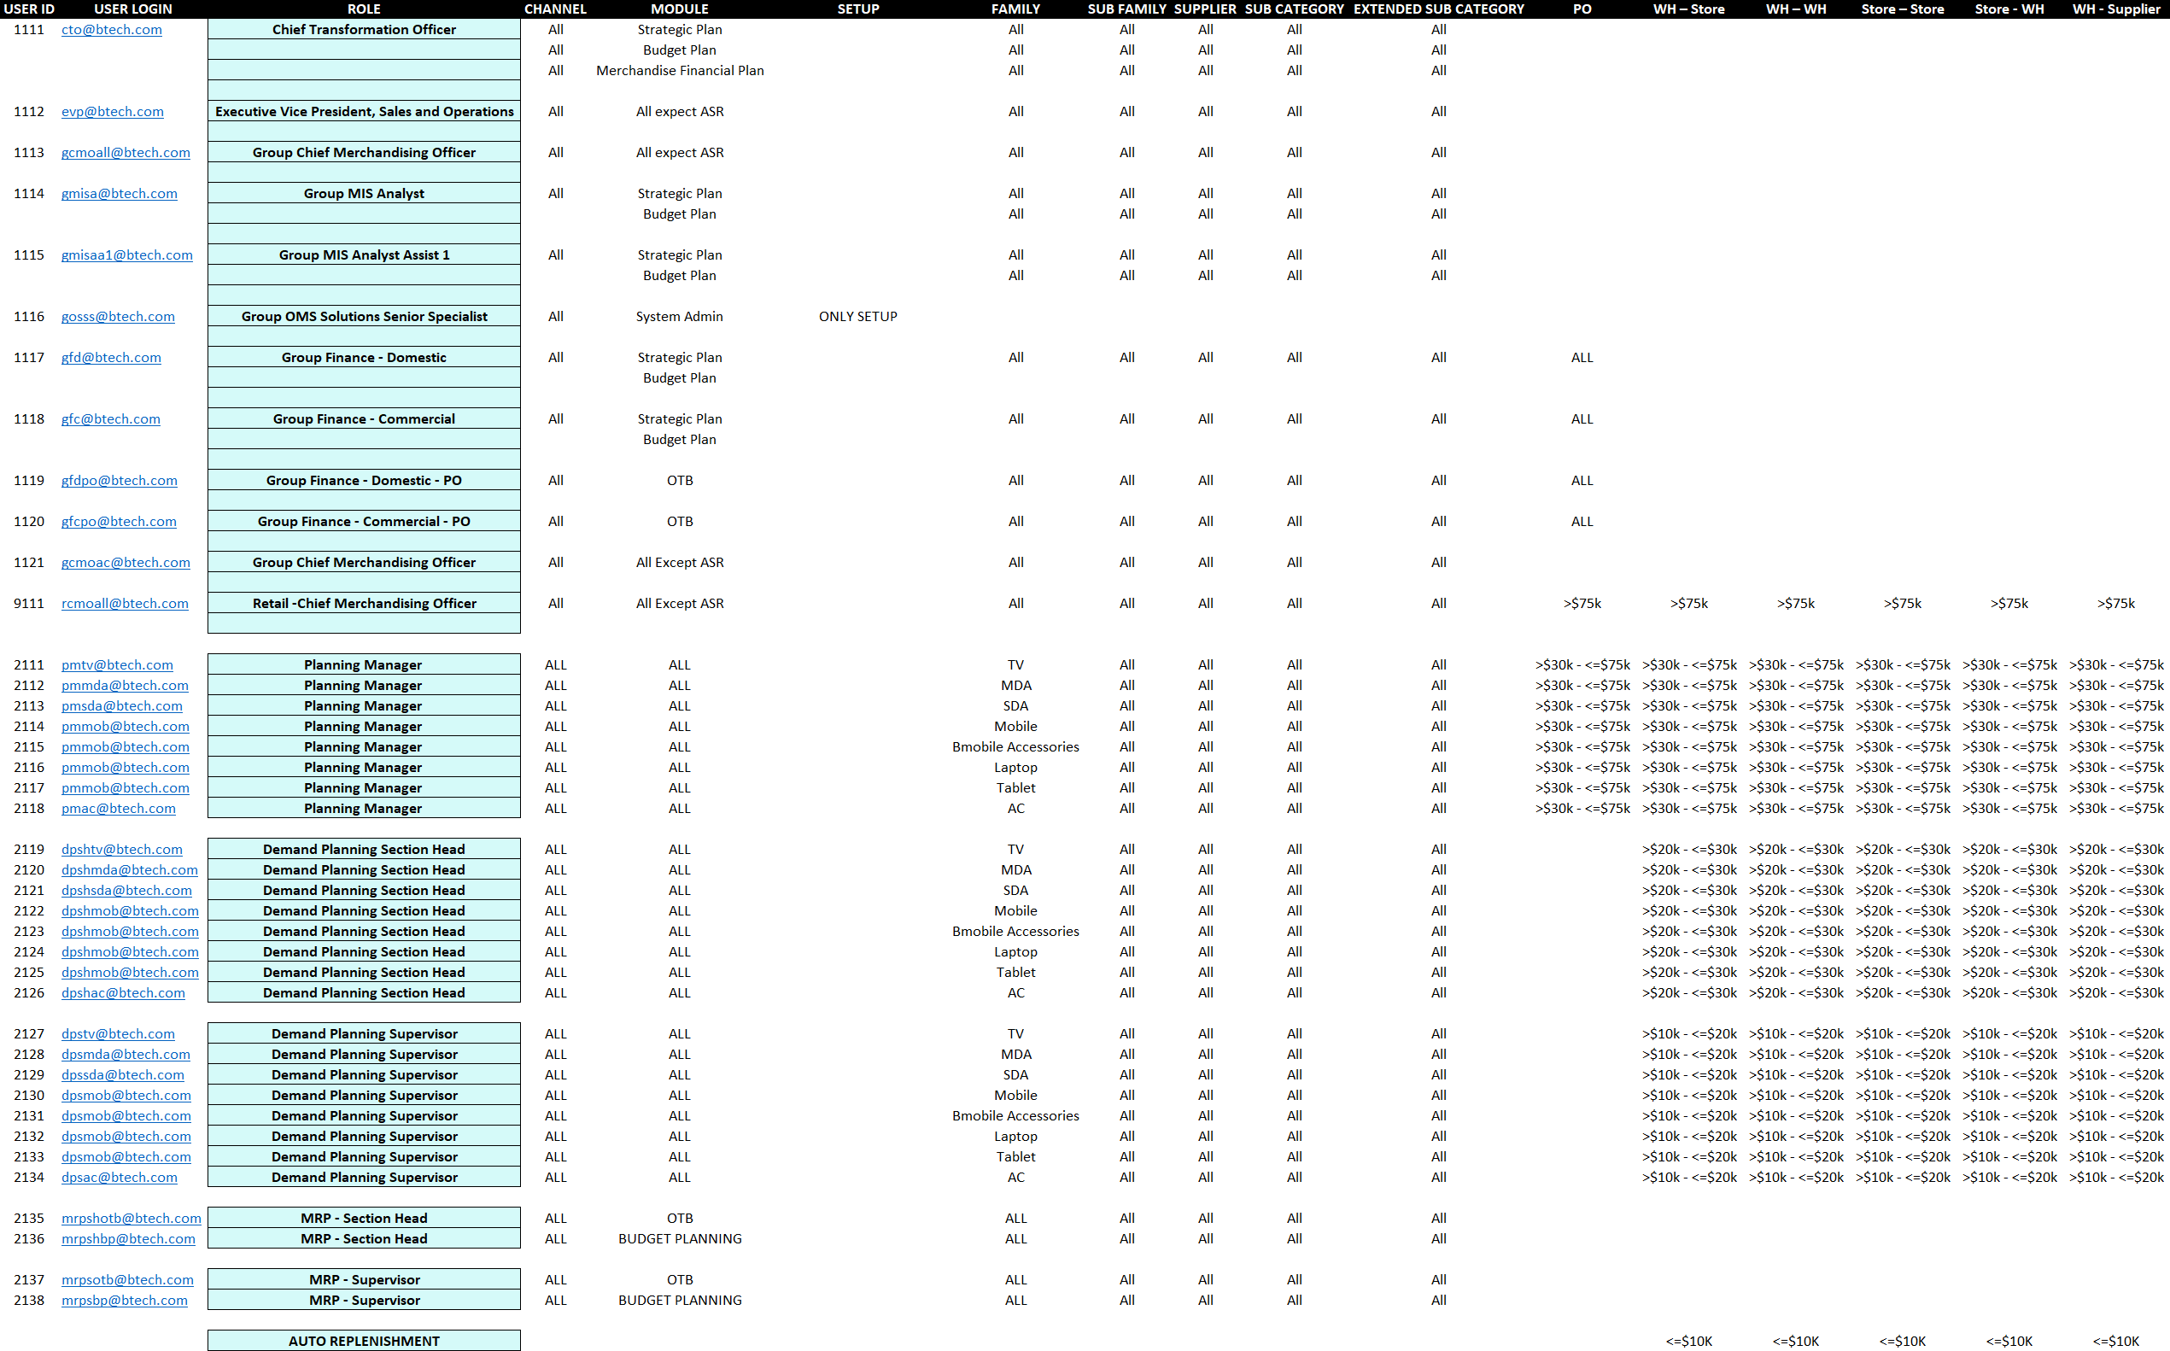

ACCESS CONTROL & approval list